RISC-V Single-Cycle Processor
Design & Implementation Report

Verilog HDL Implementation on FPGA

Computer Architecture
April 2026
Syed Sualeh Abbas, Mohsin Mujtaba, Zaid Naqvi

1. Introduction
This report documents the design and implementation of a 32-bit RISC-V single-cycle processor written in Verilog HDL. The processor implements a subset of the RV32I base integer instruction set and is intended for deployment on an FPGA development board. It supports MMIO-based I/O through on-board switches and LEDs, enabling interactive programs to run directly on hardware.

The design follows a classic five-stage data path structure: Instruction Fetch (IF), Instruction Decode (ID), Execute (EX), Memory Access (MEM), and Write-Back (WB), implemented as a single-cycle architecture.

2. Supported Instructions
The processor supports the following RISC-V RV32I instruction types:

Instruction Type | Opcode | Examples | Description
R-type | 0110011 | ADD, SUB, AND, OR, XOR, SLL, SRL, SLT | Register-to-register arithmetic and logic
I-type ALU | 0010011 | ADDI, SLTI, SLLI, SRLI | Immediate arithmetic and logic
Load (LW) | 0000011 | LW | Load 32-bit word from memory
Store (SW) | 0100011 | SW | Store 32-bit word to memory
Branch | 1100011 | BEQ, BNE | Conditional branches on equality/inequality
JAL | 1101111 | JAL | Jump and link — unconditional jump, saves PC+4

3. Top-Level Architecture
The TopLevelProcessor module is the top-level entity that instantiates and connects all sub-modules. It exposes a rich set of debug output ports to allow real-time inspection of every internal signal during simulation and on-hardware debugging.

3.1 Datapath Overview
The five-stage single-cycle datapath flows as follows:

- IF: The Program Counter (PC) drives the Instruction Memory. PC+4 is computed by PCAdder for the default sequential flow.
- ID: The fetched instruction is decoded by MainControl and ALUControl. The RegisterFile is read and the ImmGen sign-extends the immediate.
- EX: The ALU performs the required computation. ALU_Mux selects between the register value (rd2) and the sign-extended immediate as the second operand.
- MEM: AddressDecoder routes memory accesses to DataMemory, the LED peripheral, or the Switch peripheral based on the upper address bits.
- WB: A 3-way mux (Mux32_3way) selects the write-back value: ALU result, memory read data, or PC+4 (used by JAL).

3.2 PC Selection Logic
The next PC is determined by the BranchLogic module and the PC Mux:

- pc_sel = 0 → PC takes the value PC+4 (normal sequential execution).
- pc_sel = 1 → PC takes the value PC+imm (branch taken or JAL).

The BranchAdder computes PC + imm_ext for all branch targets and the JAL destination, sharing hardware between jumps and branches.

4. Module Descriptions

4.1 ProgramCounter
The ProgramCounter module holds the current instruction address. On every rising clock edge it samples the pc_in value (the next PC computed externally) into the pc_out register. An asynchronous active-high reset drives pc_out to 0x00000000, restarting execution from the first instruction.

Port | Direction | Width | Description
clk | Input | 1-bit | System clock
reset | Input | 1-bit | Asynchronous reset (active-high)
pc_in | Input | 32-bit | Next PC value from PC mux
pc_out | Output | 32-bit | Current PC (registered)

4.2 PCAdder
A purely combinational adder that computes PC + 4. This gives the default next instruction address for sequential execution. Its output (pc_plus4) is also routed to the write-back mux so that JAL can save the return address (PC+4) into the destination register.

4.3 BranchAdder
Computes PC + imm_ext combinationally. This value serves as the target address for all taken branches (BEQ, BNE) and for the JAL instruction. Because JAL and branches share the same offset encoding relative to the current PC, one adder serves both instruction types.

4.4 BranchLogic
This module centralizes all branch and jump decisions into a single combinational block, producing the pc_sel signal that drives the PC mux. The decision tree is:

- Unconditional jump: JAL (jal=1)
- Taken when alu_zero=1 (subtraction result is zero): BEQ (branch=1, funct3=000)
- Taken when alu_zero=0 (subtraction result is non-zero): BNE (branch=1, funct3=001)
- pc_sel=0, no branch taken: All other cases

BNE support was a key addition to this design. Rather than hardwiring BEQ behaviour, a case statement on funct3 allows easy extension to BLT, BGE, and other branch variants in the future.

4.5 InstructionMemory
A 64-entry, 32-bit wide read-only ROM initialized using an initial block. Word-aligned access is achieved by indexing with address[7:2] (dividing the byte address by 4). During reset the module outputs a 32-bit zero rather than a potentially invalid instruction.
The ROM is pre-loaded with a test program that exercises the full instruction set. The program reads from the on-board switches, displays the value on the LEDs, counts down through a software delay loop, decrements the switch value, and repeats until it reaches zero, then halts.
For Example: FSM COUNTER PROGRAM FOR PART A:

Address | Instruction | Assembly | Purpose
0x00 | 0x20000093 | addi x1, x0, 0x200 | x1 = Switch MMIO base address
0x04 | 0x10000113 | addi x2, x0, 0x100 | x2 = LED MMIO base address
0x08 | 0x0000a183 | lw x3, 0(x1) | READ_SW: load switch value
0x0C | 0xfe018ee3 | beq x3, x0, -4 | Spin until switch != 0
0x10 | 0x00312023 | sw x3, 0(x2) | DISPLAY: write x3 to LEDs
0x14 | 0x0007a313 | addi x6, x0, 122 | Load delay seed
0x18 | 0x00c31313 | slli x6, x6, 12 | Scale to ~500 000 iterations
0x1C | 0xfff30313 | addi x6, x6, -1 | D_INNER: decrement counter
0x20 | 0xfe031ce3 | bne x6, x0, -8 | Loop until counter = 0 (BNE test)
0x24 | 0xfff18183 | addi x3, x3, -1 | Decrement display value
0x28 | 0xfe019ce3 | bne x3, x0, -24 | Return to DISPLAY if x3 != 0 (BNE test)
0x2C | 0x00012023 | sw x0, 0(x2) | Turn off LEDs
0x30 | 0x0000006f | jal x0, 0 | Halt — infinite self-loop (JAL test)

4.6 MainControl
The MainControl module decodes the 7-bit opcode and drives all control signals across the datapath. The module uses a combinational always block with safe defaults (all zeros) before a case statement, ensuring no latches are inferred.

Opcode | Instruction | reg_write | alu_src | mem_read | mem_write | branch | jal | wb_sel | alu_op
0110011 | R-type | 1 | 0 | 0 | 0 | 0 | 0 | 00 | 10
0010011 | I-type ALU | 1 | 1 | 0 | 0 | 0 | 0 | 00 | 10
0000011 | Load (LW) | 1 | 1 | 1 | 0 | 0 | 0 | 01 | 00
0100011 | Store (SW) | 0 | 1 | 0 | 1 | 0 | 0 | 00 | 00
1100011 | Branch | 0 | 0 | 0 | 0 | 1 | 0 | 00 | 01
1101111 | JAL | 1 | 1 | 0 | 0 | 0 | 1 | 10 | 00

The 2-bit wb_sel signal was introduced to replace the single-bit mem_to_reg, enabling a three-way write-back selection: 00 = ALU result, 01 = memory read data, 10 = PC+4 (required for JAL to save the return address).

4.7 ALUControl
ALUControl translates the 2-bit alu_op signal (from MainControl) together with funct3 and funct7 fields into a 4-bit alu_ctrl code consumed by the ALU. The three-level decode scheme mirrors the standard RISC-V control hierarchy:

alu_op | Source | alu_ctrl | ALU Operation
00 | Load / Store | 0000 | ADD (address computation)
01 | Branch | 0001 | SUB (equality comparison via zero flag)
10 / funct3=000 | R-type / I-type | 0000 or 0001 | ADD or SUB (funct7 selects)
10 / funct3=001 | SLLI / SLL | 0101 | Logical left shift
10 / funct3=010 | SLTI / SLT | 0111 | Signed less-than (new)
10 / funct3=100 | XOR | 0100 | Bitwise XOR
10 / funct3=101 | SRLI / SRL | 0110 | Logical right shift
10 / funct3=110 | OR | 0011 | Bitwise OR
10 / funct3=111 | AND | 0010 | Bitwise AND

4.8 RegisterFile
A 32-register, 32-bit wide synchronous register file. Key design properties:

- x0 is hardwired to zero: reads always return 0, writes are silently discarded.
- Two independent asynchronous read ports (rs1, rs2) for simultaneous operand fetch.
- One synchronous write port (rd) triggered on the rising clock edge when reg_write=1.
- Asynchronous reset clears all registers to zero in a single cycle.

4.9 ImmGen (Immediate Generator)
The ImmGen module reconstructs and sign-extends the immediate field from the instruction encoding. Different instruction formats scatter the immediate bits across non-contiguous fields; ImmGen re-assembles them correctly for each type:

Format | Instruction Type | Immediate Bits
I-type | ADDI, LW, SLTI, SLLI, etc. | inst[31:20], sign-extended to 32 bits
S-type | SW | inst[31:25] ++ inst[11:7], sign-extended
B-type | BEQ, BNE | inst[31], inst[7], inst[30:25], inst[11:8], 0 — sign-extended (byte offset)
J-type | JAL | inst[31], inst[19:12], inst[20], inst[30:21], 0 — sign-extended (byte offset)

Both B-type and J-type immediates are implicitly multiplied by 2 (appended with a '0' LSB) because all RISC-V instructions are 4-byte aligned, making the LSB of any branch/jump offset always zero.

4.10 ALU
The Arithmetic Logic Unit is an 8-operation combinational block. The 4-bit alu_ctrl input selects the operation. A zero flag is derived from the result and used by BranchLogic for conditional branches.

alu_ctrl | Operation | Expression
0000 | ADD | A + B
0001 | SUB | A - B
0010 | AND | A & B
0011 | OR | A | B
0100 | XOR | A ^ B
0101 | SLL (Shift Left Logical) | A << B[4:0]
0110 | SRL (Shift Right Logical) | A >> B[4:0]
0111 | SLT (Set Less Than) | signed(A) < signed(B) ? 1 : 0

4.11 Mux32 (2-Input Multiplexer)
A generic 32-bit, 2-input multiplexer used in two places: the ALU operand-B mux (selects between rd2 and imm_ext) and the PC mux (selects between PC+4 and PC+branch/jump target).
A 32-bit, 3-input multiplexer used exclusively in the Write-Back stage. The 2-bit sel input chooses among: ALU result (00), memory read data (01), or PC+4 (10). The PC+4 path is what allows JAL to write the return address into the destination register without any additional hardware beyond this wider mux.

4.13 AddressDecoder
The AddressDecoder acts as an MMIO bus fabric. It decodes the upper address bits [9:8] to route memory transactions to one of three sub-modules:

Address Bits [9:8] | Peripheral | Base Address | Access Type
00 | DataMemory | 0x000 | Read / Write
01 | LEDs | 0x100 | Write only
10 | Switches | 0x200 | Read only

Read data is selected combinationally: if a data memory or switch access is active, the corresponding read_data is forwarded; otherwise, 32'd0 is returned. This ensures X-propagation does not reach the register file during write-only or non-memory instructions.

4.14 DataMemory
A 512-entry, 32-bit synchronous RAM. Writes are clocked; reads are asynchronous (combinational). The address is word-aligned using bits [10:2] (ignoring the two LSBs). Asynchronous reset zeroes the entire memory array.

4.15 LEDs
A 16-bit output register connected to the physical LED bank of the FPGA. It captures write_data[15:0] on the rising clock edge when write_enable is asserted. The leds_out wire drives the top-level output port directly and can be connected to on-board LEDs or a testbench monitor.

4.16 Switches
A 16-bit input sampler for the physical slide-switches of the FPGA. The raw switches_in signal is registered (sampled) on each rising clock edge to avoid metastability. The registered value is presented as a zero-extended 32-bit word on read_data when read_enable is asserted.

5. Design Extensions and Key Changes

5.1 BNE Support
BNE (Branch if Not Equal) was added by extending BranchLogic with a case statement on funct3. For BEQ the branch is taken when alu_zero=1; for BNE it is taken when alu_zero=0. Both use the same subtract-and-check-zero mechanism in the ALU.

5.2 JAL Instruction
JAL (Jump and Link) required three coordinated changes across modules:
- MainControl: A new jal output signal is asserted for opcode 1101111. wb_sel is set to 2'b10 so the write-back mux selects PC+4 (the return address). reg_write=1 ensures the return address is committed to rd.
- BranchLogic: When jal=1, pc_sel is unconditionally set to 1, directing the PC mux to the BranchAdder output (PC + J-type immediate).
- Mux32_3way (WB mux): Upgraded from a 1-bit-select 2-way mux to a 2-bit-select 3-way mux, adding the PC+4 input required by JAL.

5.3 SLTI Instruction
SLTI (Set Less Than Immediate) was enabled by adding funct3=010 to the ALUControl decode table, mapping it to alu_ctrl=4'b0111 (the SLT operation already implemented in the ALU). No changes to the ALU itself were required.

6. Test Program Behavior
The ROM-resident test program follows the procedure written below: Which includes part A and part C of the project:
PROGRAM 1: FSM COUNTER
(Code done in Lab 10)
- Initialise: Load switch and LED MMIO addresses into x1 and x2 (ADDI).
- Read Switches: Poll the switch MMIO register until a non-zero value is read (LW + BEQ loop).
- Display: Write the switch value to the LED MMIO register (SW).
- Delay Loop: Load a large counter (~500 000), shift it left 12 places (SLLI), then count down to zero using BNE — producing a visible human-scale delay on hardware.
- Decrement: Subtract 1 from the displayed value (ADDI with -1).
- Repeat or End: If the value is non-zero, branch back to Display (BNE); otherwise turn off LEDs (SW x0) and halt via infinite JAL self-loop.
This program tests BEQ, BNE (in both the delay and decrement loops), ADDI, SLLI, LW, SW, and JAL, covering all major datapath paths including the new JAL write-back and BNE branch logic.

PROGRAM 2: 3- New type of Instructions on Processor
- The program begins by loading fixed values into registers, including the switch address, LED address, and a constant value of 16. This constant acts as a safety limit against which the user input will be compared.
- The processor then reads a value from the switches into register x6. This value represents the user’s input and is the main variable used in the program.
- The first newly implemented instruction is SLTI (Set Less Than Immediate). This instruction compares the constant value 16 (stored in x5) with the input value in x6. If the input is greater than 16, the result of the comparison sets register x7 to 1; otherwise, it sets it to 0. This allows the processor to make a decision based on a numerical condition, which was not possible with only basic arithmetic instructions.
- The second key addition is the use of enhanced branch logic through BNE (Branch if Not Equal). In the loop, the processor checks whether the value in x6 has reached zero. If it has not, the program branches back and continues the loop. This enables iterative behavior, allowing repeated execution of instructions until a condition is met.
- The third newly implemented instruction is JAL (Jump and Link). This is used in two places. First, it allows the processor to jump to an error-handling section if the input exceeds the safe limit. Second, it is used to halt execution by creating an infinite loop. This instruction is important because it enables unconditional jumps, which were not supported in the basic design.
- If the input value is within the safe range, the processor proceeds to perform the arithmetic operation. It initializes a sum register and repeatedly adds the current value of x6 to the sum while decrementing x6 in each iteration.
- The loop continues until x6 becomes zero, at which point the total sum has been computed. This demonstrates how the processor combines arithmetic operations with branching to perform a complete algorithm.
- Once the computation is complete, the result is written to the LED output so that the user can observe it.

INSTRUCTION MEMORY: BNE, JAL, SLTI
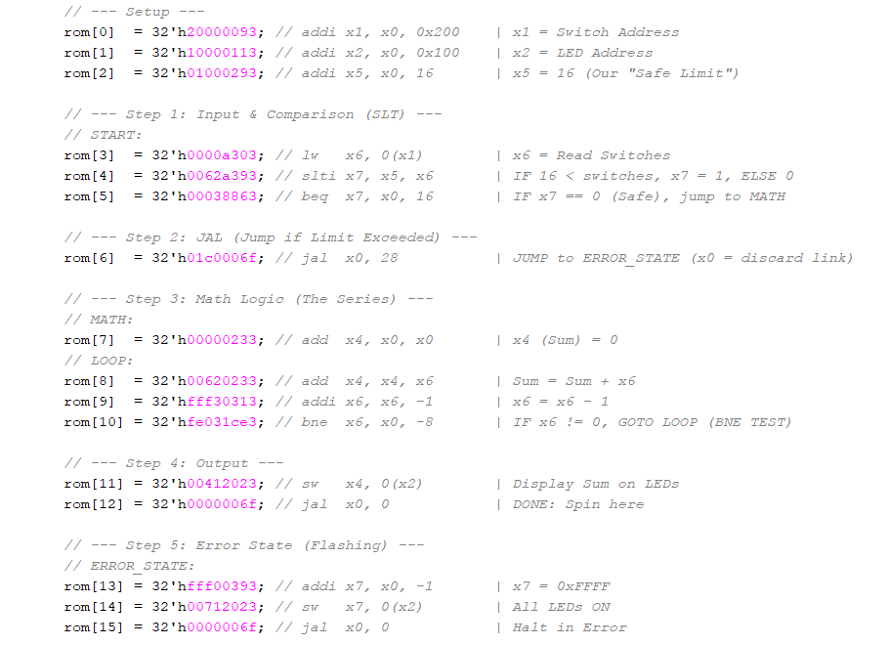

PROGRAM 3: ARTHIMETIC SEQUENCE
- The processor first sets up the memory-mapped addresses by loading the switch address into register x1 and the LED address into register x2. These addresses are later used to read user input and display output.
- It then continuously reads from the switches until a non-zero value is detected. This first value is treated as the starting term of the sequence and is stored in register x3.
- After obtaining the starting value, the processor reads from the switches again to get the common difference. It again waits until a non-zero value is provided, ensuring that the sequence has a meaningful step size. This value is stored in register x5.
- The starting value is copied into register x4, which acts as the current term of the arithmetic sequence. This register will be updated in every iteration.
- In each cycle of the main loop, the current value in x4 is written to the LED output. This allows the user to observe the sequence as it evolves step by step.
- The processor then updates the current term by adding the common difference stored in x5 to x4. This produces the next term in the arithmetic sequence.
- A delay loop is introduced using register x6. The processor repeatedly decrements this register and checks whether it has reached zero. This delay slows down the execution so that changes on the LEDs are visible to the human eye.
- Once the delay completes, the processor jumps back to the beginning of the loop without any terminating condition. This creates a continuous sequence.
- As a result, the system generates an arithmetic progression where each new value is obtained by adding a fixed common difference to the previous value, and each term is displayed on the LEDs in real time.
INSTRUCTION MEMORY: Arithmetic Sequence:
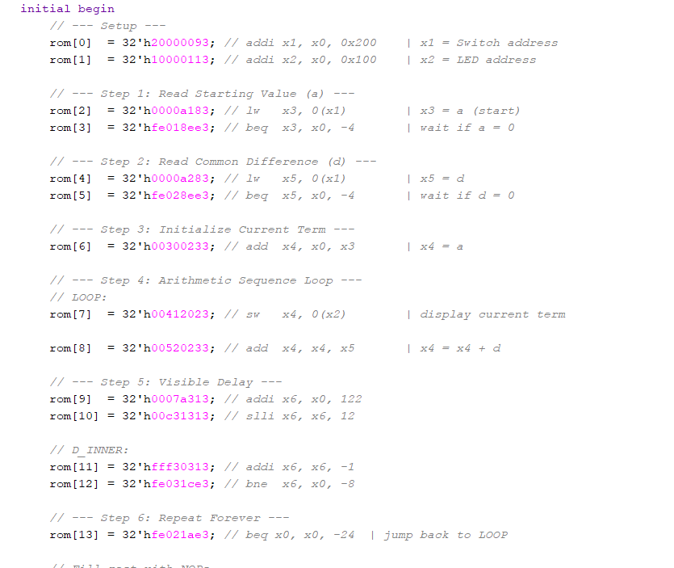

7. Conclusion
The RISC-V single-cycle processor successfully implements a functional RV32I subset capable of executing a real I/O program. The design is modular, with each hardware unit encapsulated in Verilog module, making it easy to verify, extend, and synthesise.
Key design decisions, such as the 3-way WB mux, the generalized BranchLogic module, and the shared BranchAdder for both branches and JAL, minimize hardware duplication while keeping the control logic easy to trace.

Signals List

Signal | Width | Description
pc_current | 32-bit | Current instruction address (PC register output)
pc_next | 32-bit | Next PC — output of PC mux; registered on next clock edge
pc_plus4 | 32-bit | Sequential next instruction (PC + 4)
pc_branch | 32-bit | Branch/jump target (PC + sign-extended immediate)
pc_sel | 1-bit | 0 = sequential, 1 = branch/jump taken
instruction | 32-bit | Full 32-bit instruction word from ROM
imm_ext | 32-bit | Sign-extended immediate for current instruction
rd1 / rd2 | 32-bit | Register file read data for rs1 / rs2
alu_operand_b | 32-bit | ALU B input — rd2 or imm_ext, selected by alu_src
alu_result | 32-bit | ALU computed output
alu_zero | 1-bit | 1 when alu_result == 0 (used by branch logic)
alu_ctrl | 4-bit | Selects ALU operation
alu_op | 2-bit | Coarse ALU operation type from MainControl
reg_write | 1-bit | Enables write to register file
mem_read | 1-bit | Enables memory / MMIO read
mem_write | 1-bit | Enables memory / MMIO write
alu_src | 1-bit | Selects ALU operand B: 0 = rd2, 1 = imm_ext
mem_to_reg | 1-bit | Legacy single-bit WB select (superseded by wb_sel)
wb_sel | 2-bit | WB mux select: 00=ALU, 01=MEM, 10=PC+4
branch | 1-bit | Indicates a conditional branch instruction
jal | 1-bit | Indicates a JAL instruction
write_back_data | 32-bit | Value written back to the register file
mmio_read_data | 32-bit | Data returned from MMIO / data memory read

